1. **Given the provided data, what are three conclusions that we can draw about crowdfunding campaigns?**

Answer: overall campaign is successful

1. Campaign in the **Theatre** is more successful than other categories.
2. In this campaign **Plays** sub-category got maximum success.
3. Majority of campaigns are successful in **June and July** months.
4. **What are some limitations of this dataset?**

Answer:

* 1. It would be good to convert all the donation in one currency to consistent comparison for the collection per country.
  2. If we are finding outcome per Categories or sub-categories, Not all subcategories were used for the campaign over the period

1. **What are some other possible tables and/or graphs that we could create, and what additional value would they provide?**

Answer:

* 1. We can create table and graph for average Donation we received per category over the years. In this we can filter by Country and Outcome to identify which year donation dropped or increased.

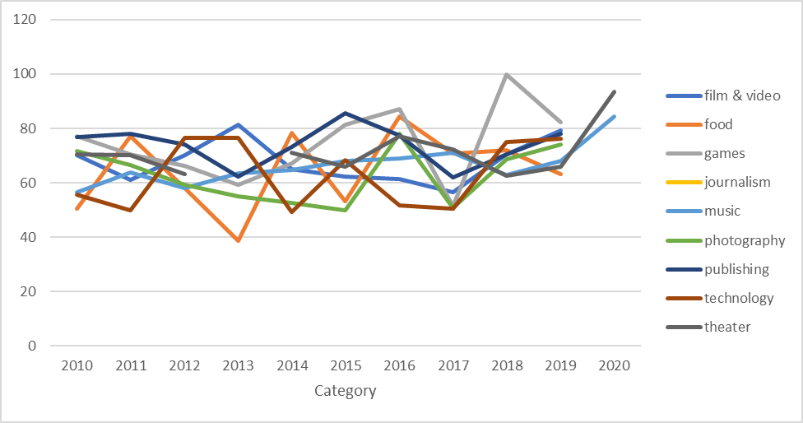

* 1. We can create a graph showing campaign success per Country by the Quarter. With the following graph we can say US campaign are more successful in 1st Quarter. In IT 2nd Quarter is more successful than other three quarters.

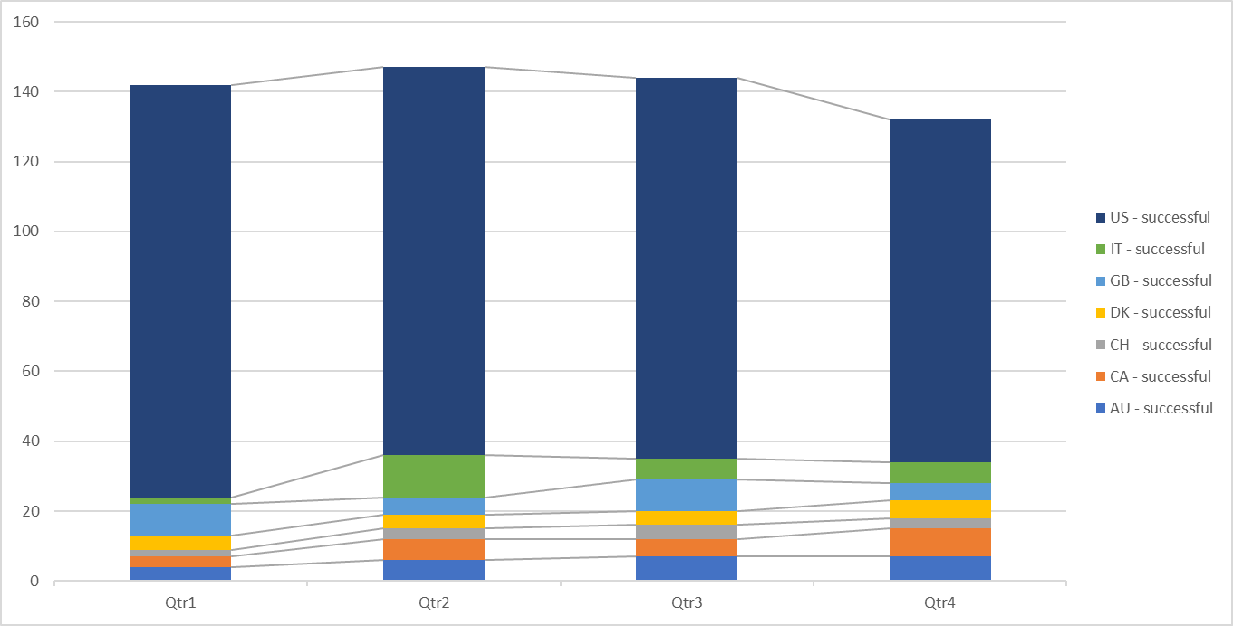

**Statistical Analysis**

**Determine whether the mean or the median better summarises the data?**

To summarise the data Median value is more reliable.

**Determine if there is more variability with successful or unsuccessful campaigns. Does this make sense? Why or why not?**

Based on variance value , variance of successful campaigns is higher than Unsuccessful campaigns, suggesting that backers count for successful campaigns is deviated more from mean than unsuccessful campaigns. Same in Std dev, successful campaigns std dev is higher than unsuccessful campaigns , which indicates more variability in successful campaigns backers count.